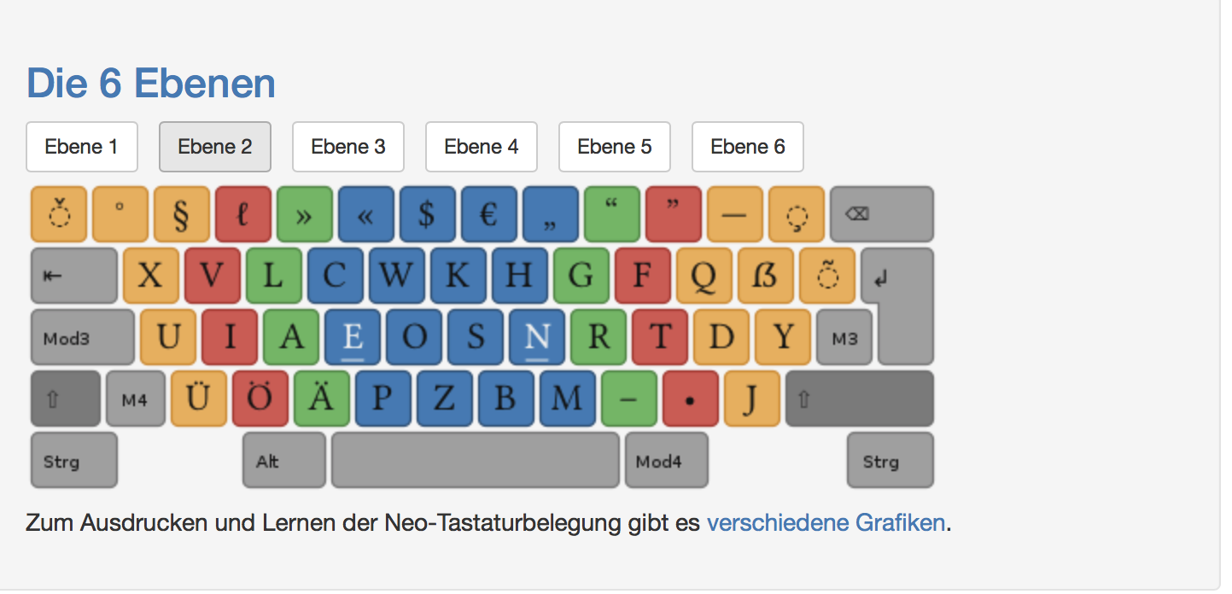r,r r,r r,r r,r r,r r,r r,r r,r r,r r,r r,r r,r r,r r,r r,r r,r r,r r,r r,r r,r r,r r,r r,r

r,r r,r r,r r,r r,r r,r r,r r,r r,r r,r r,r r,r r,r r,r r,r r,r r,r r,r r,r r,r r,r r,r r,r

r,r r,r r,r r,r r,r r,r r,r r,r r,r r,r r,r r,r r,r r,r r,r r,r r,r r,r r,r r,r r,r r,r r,r

r,n r,n r,n r,n r,n r,n r,n r,n r,n r,n r,n r,n r,n r,n r,n r,n r,n r,n r,n r,n r,n r,n r,n r,n r,n r,n r,n

r,n r,n r,n r,n r,n r,n r,n r,n r,n r,n r,n r,n r,n r,n r,n r,n r,n r,n r,n r,n r,n r,n r,n r,n r,n r,n r,n

r,t r,t r,t r,t r,t r,t r,t r,t r,t r,t r,t r,t r,t r,t r,t r,t r,t r,t r,t r,t r,t r,t r,t r,t r,t r,t r,t

r,t r,t r,t r,t r,t r,t r,t r,t r,t r,t r,t r,t r,t r,t r,t r,t r,t r,t r,t r,t r,t r,t r,t r,t r,t r,t r,t

r,d r,d r,d r,d r,d r,d r,d r,d r,d r,d r,d r,d r,d r,d r,d r,d r,d r,d r,d r,d r,d r,d

r,d r,d r,d r,d r,d r,d r,d r,d r,d r,d r,d r,d r,d r,d r,d r,d r,d r,d r,d r,d r,d r,d

d,r d,r d,r d,r d,r d,r d,r d,r d,r d,r d,r d,r d,r d,r d,r d,r d,r d,r d,r d,r d,r d,r

d,r d,r d,r d,r d,r d,r d,r d,r d,r d,r d,r d,r d,r d,r d,r d,r d,r d,r d,r d,r d,r d,r

t,r t,r t,r t,r t,r t,r t,r t,r t,r t,r t,r t,r t,r t,r t,r t,r t,r t,r t,r t,r t,r t,r t,r t,r t,r t,r t,r t,r

t,r t,r t,r t,r t,r t,r t,r t,r t,r t,r t,r t,r t,r t,r t,r t,r t,r t,r t,r t,r t,r t,r t,r t,r t,r t,r t,r t,r

n,r n,r n,r n,r n,r n,r n,r n,r n,r n,r n,r n,r n,r n,r n,r n,r n,r n,r n,r n,r n,r n,r n,r n,r n,r n,r n,r n,r

n,r n,r n,r n,r n,r n,r n,r n,r n,r n,r n,r n,r n,r n,r n,r n,r n,r n,r n,r n,r n,r n,r n,r n,r n,r n,r n,r n,r